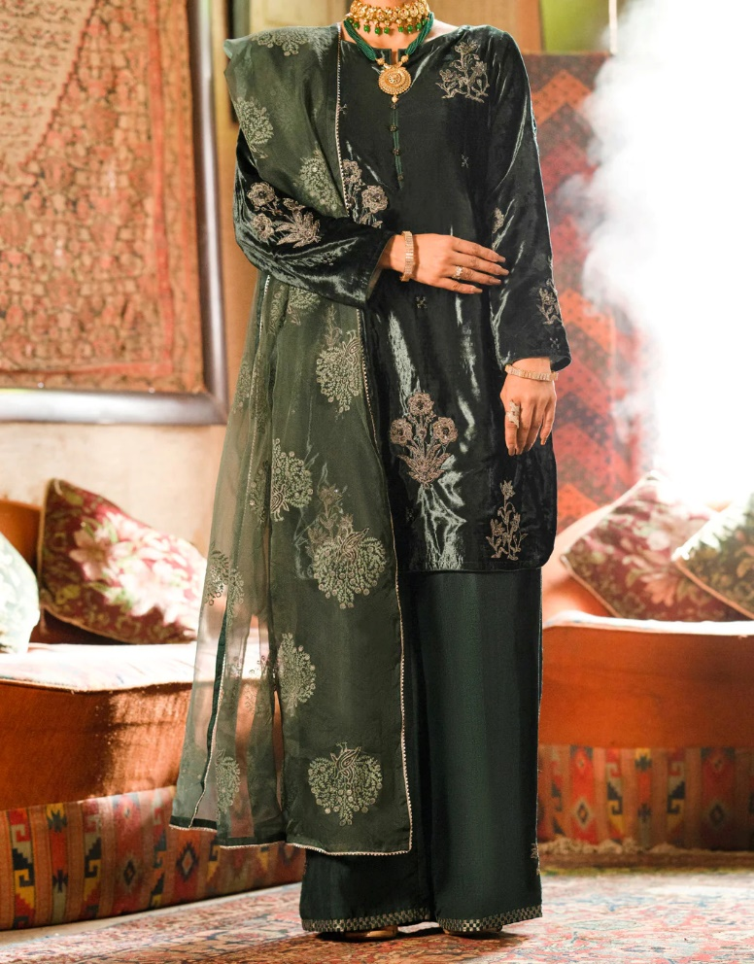

TEAL VELVET 3 PIECE FORMAL UNSTITCHED - AL-3PS-LS-UN-440

Sale priceRs.11,962.50

ADDITIONAL INFO

|  |  |
| --- | --- |
| Color | TEAL |
| Pieces | 3 Pieces |
| Fit Type | — |
| Fabric | Velvet, |
| Season | Winter Collection |
| Disclaimer | Due to the photographic lighting & different screen calibrations, the colors of the original product may slightly vary from the picture. |